VINH LONG UNIVERSITY OF TECHNOLOGY EDUCATION

**PRACTICE CENTER**

TEST PROJECT

PRACTICAL SKILLS

MODULE 1: WEB DESIGN

**Exam Paper Code: WD01**

|  |  |
| --- | --- |
| **SCHOOL LEADERSHIP** | **CHIEF SUBCOMMITTEE ON EXAM DEVELOPMENT** |

**Vinh Long, month 12/2020**

**GUIDE CONTESTANTS**

**Time:**

* Preparation Time: 05 minutes
* Time Duration: 150 minutes
* Break Time: 10 minutes

**Scores:**

|  |  |  |
| --- | --- | --- |
| **Exam content** | | **Marks** |
| 1 | Programming with HTML/CSS | 30 |
| 2 | Programming with JavaScript | 30 |
| 3 | Use the MySQL | 10 |
| 4 | Programming with PHP | 30 |
| **Total Marks** | | **100** |

**Candidates are required to note:**

* Ensure safety standards of health and computer
* Do the test independently without discussing while doing the test
* Comply with regulations of exam room and proctor’s instructions
* Fill the information in the form
* Complete all requirements in the content of the exam
* Do not use documents, the Internet and other communication devices during the assignment
* If the exam does not have special requirement for the file name and storage location, contestants save all exam file name in the folder as following format**: D:\WorkSkills\Web Design**

***<Student’s Name>_<*** ***Student code >[.<*** ***extension >]***

**CONTENT OF THE TEST**

**Question 1:**

**Programming with** **HTML/CSS:**

Use HTML/CSS code to design the following page:

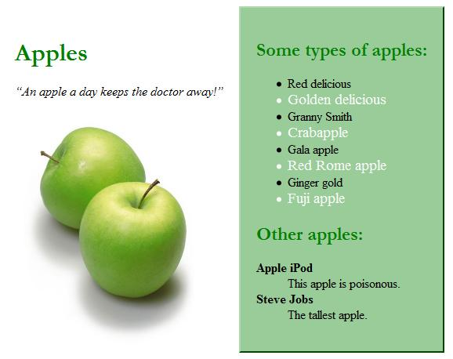

# **DESCRIPTION OF PROJECT AND TASKS**

* + Make all headings green, and make them use Garamond font or any serif font on the system.
  + The quote should be italicized.
  + The apples picture name is greenapples.jpg. It also links to <http://www.apple.com/>.
  + All pictures should have no borders and be 250 pixels wide.
  + The right section has a 2 pixel wide outset green border and a background of #99cc99.
  + Every other line in the "types of apples" list is white and its font-size is 120% as large as the other list items.
  + The definition terms are bolded.
  + Notice that there are two distinct sections on the page.
  + The content inside each section should be 20 pixels away from all edges.

**Question 2:**

**Programming with** **JavaScript:**

Write the necessary JavaScript code **garden.js** for the functionality of the following page:

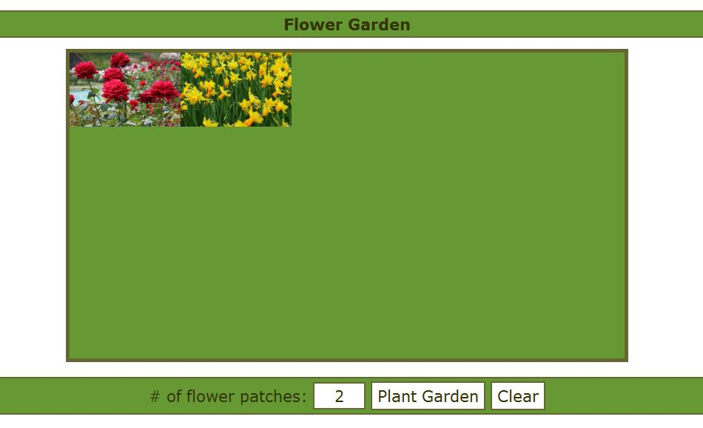

**DESCRIPTION OF PROJECT AND TASKS**

* + This page allows the user to plant a number of flower patches in their garden.
  + The input box for the # of flower patches has an id of "count".
  + The "Plant Garden" button has an id of "plant".
  + The "Clear" button has an id of "clear".
  + When the user clicks on "Plant Garden" the page should generate the # of flower patches given in the input box on the page.
  + The flower patches are images; either daffodils.jpg or roses.jpg.
  + Choose randomly what kind of flower patch to show.
  + Clicking on the "Clear" button removes all flower patches from the garden.

**Question 3:**

**Use the MySQL create database Cities:**

***The database schema:***

|  |  |  |  |  |  |  |
| --- | --- | --- | --- | --- | --- | --- |
| **Countries** | | | | | | |
| **code** | **Name** | **Continent** | **independence_year** | **population** | **gnp** | **head_of_state** |
| AFG | Afghanistan | Asia | 1919 | 22720000 | 5976.0 | Mohammad Omar |
| NLD | Netherlands | Europe | 1581 | 15864000 | 371362.0 | Beatrix |
| ... | ... | ... | ... | ... | ... | ... |

|  |  |  |  |  |
| --- | --- | --- | --- | --- |
| **Cities** | | | | |
| **Id** | **Name** | **country_code** | **district** | **population** |
| 3793 | New York | USA | New York | 8008278 |
| 1 | Los Angeles | USA | California | 3694820 |
| ... | ... | ... | ... | ... |

|  |  |  |  |
| --- | --- | --- | --- |
| **Languages** | | | |
| **country_code** | **language** | **official** | **percentage** |
| AFG | Pashto | T | 52.4 |
| NLD | Dutch | T | 95.6 |
| ... | ... | ... | ... |

**DESCRIPTION OF PROJECT AND TASKS**

Some countries have two cities with the same name. For example, there are several cities in the USA named Springfield, which is part of the reason that name was chosen for the home town of the Simpsons.

Using the world database, find all such cities where there are two or more cities within the same country that have the same name. Show both the country name and the city name. Eliminate duplicate results and order by the country name, breaking ties by the city name.

This is the output you should get:

+--------------------+--------------+

| country | city |

+--------------------+--------------+

| China | Jining |

| China | Kaiyuan |

| China | Yichun |

| Indonesia | Depok |

| Mexico | Guadalupe |

| Mexico | La Paz |

| Mexico | Matamoros |

| Philippines | San Carlos |

| Philippines | San Fernando |

| Philippines | San Jose |

| Russian Federation | Zeleznogorsk |

| United States | Arlington |

| United States | Aurora |

| United States | Columbus |

| United States | Kansas City |

| United States | Richmond |

| United States | Springfield |

+--------------------+--------------+

17 rows in set (14.48 sec)

**Question 4:**

**Programming with** **PHP:**

Use database **Cities** from module C write a page that displays the result of a query in PHP. Start from the following file [cities.php](https://www.webstepbook.com/supplements/labsection/section9-query/cities.php) (initial HTML/CSS code use cities.css from source folder)



And page **show.php:**

[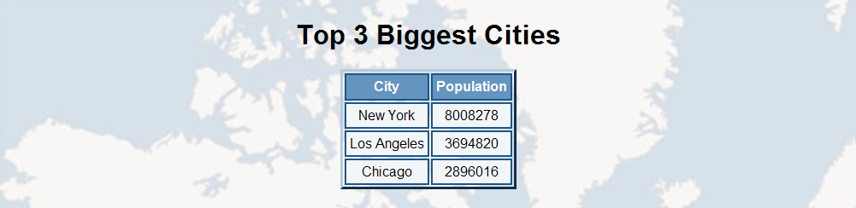](https://webster.cs.washington.edu/labs/09sp/section9/cities.php)

**DESCRIPTION OF PROJECT AND TASKS**

* + Use banner and background from source folder.
  + Drop-down list "country" has an id of "country", it show name country.
  + Drop-down list "top" has an id of "top", it show top largest cities.
  + The "Submit Query" button has an id of "query", It also links to show.php.
  + Page show.phpshow top largest cities of country selected.

**GENERAL TRANSCRIPT**

|  |  |  |  |
| --- | --- | --- | --- |
| **Exam content** | | **Maximum Marks** | **Achieved**  **Marks** |
| 1 | Programming with HTML/CSS | 30 |  |
| 2 | Programming with JavaScript | 30 |  |
| 3 | Use the MySQL | 10 |  |
| 4 | Programming with PHP | 30 |  |
| **Total Marks** | | **100** |  |

**TEST TIME**

|  |  |  |  |  |  |  |  |
| --- | --- | --- | --- | --- | --- | --- | --- |
| **Get to know the equipment** | | **Time Duration** | | **Break Time** | | | |
| Starting time |  | Starting time |  | Starting time |  | Starting time |  |
| Ending time |  | Ending time |  | Ending time |  | Ending time |  |

**TEACHERS’ SIGNATURE**

|  |  |  |  |  |
| --- | --- | --- | --- | --- |
| **1** | **2** | **3** | **4** | **5** |
|  |  |  |  |  |

**ASSESSMENT GUIDELINES**

|  |  |  |  |  |
| --- | --- | --- | --- | --- |
| **1** | **Technical Press the network cable** | **Maximum Marks** | **Achieved**  **Marks** | **Note** |
| 1.1 | Animation doesn’t distract the eye when reading over website content. | 1 |  |  |
| 1.2 | Animation fits in with the design of the website. | 1 |  |  |
| 1.3 | Uniqueness of the animation. | 1 |  |  |
| 1.4 | Layout | 4 |  |  |
| 1.5 | Make all headings green, and make them use Garamond font or any serif font on the system. | 3 |  |  |
| 1.6 | The quote italicized. | 3 |  |  |
| 1.7 | The apples picture name is greenapples.jpg. It also links to http://www.apple.com | 3 |  |  |
| 1.8 | All pictures should have no borders and be 250 pixels wide. | 2 |  |  |
| 1.9 | The right section has a 2 pixel wide outset green border and a background of #99cc99. | 2 |  |  |
| 1.10 | Every other line in the "types of apples" list is white and its font-size is 120% as large as the other list items. | 2 |  |  |
| 1.11 | The definition terms are bolded. | 2 |  |  |
| 1.12 | there are two distinct sections on the page. | 3 |  |  |
| 1.13 | The content inside each section should be 20 pixels away from all edges. | 3 |  |  |
| **Total Marks** | | **30** |  |  |

|  |  |  |  |  |
| --- | --- | --- | --- | --- |
| **2** | **Design the network model using VISIO software according to the system requirements** | **Maximum Marks** | **Achieved**  **Marks** | **Note** |
| 2.1 | Animation doesn’t distract the eye when reading over website content. | 1 |  |  |
| 2.2 | Animation fits in with the design of the website. | 1 |  |  |
| 2.3 | Uniqueness of the animation. | 1 |  |  |
| 2.4 | Page layout has all required sections. | 5 |  |  |
| 2.5 | Box for "count". | 5 |  |  |
| 2.6 | Button "Plant Garden". | 5 |  |  |
| 2.7 | Button "Clear". | 5 |  |  |
| 2.8 | Use images; either daffodils.jpg or roses.jpg. | 4 |  |  |
| 2.9 | Choose randomly what kind of flower patch to show. | 3 |  |  |
| 2.10 | Animation doesn’t distract the eye when reading over website content. | 1 |  |  |
| **Total Marks** | | **30** |  |  |

|  |  |  |  |  |
| --- | --- | --- | --- | --- |
| **3** | **Use Packet Tracer software to configure the above system** | **Maximum Marks** | **Achieved**  **Marks** | **Note** |
| 3.1 | Tables with all necessary fields have been created | 3 |  |  |
| 3.2 | Data types / lengths are appropriate on all fields | 1 |  |  |
| 3.3 | Foreign key constraints have been used where appropriate | 1 |  |  |
| 3.4 | The data for the menus has been inserted into the tables | 1 |  |  |
| 3.5 | Find all such cities where there are two or more cities within the same country that have the same name | 4 |  |  |
| **Total Marks** | | **10** |  |  |

|  |  |  |  |  |
| --- | --- | --- | --- | --- |
| **4** | **Use Packet Tracer software to configure the above system** | **Maximum Marks** | **Achieved**  **Marks** | **Note** |
| 4.1 | Website that is connected to the database | 3 |  |  |
| 4.2 | Logical Website layout | 2 |  |  |
| 4.3 | Images have been used effectively in the designs | 2 |  |  |
| 4.4 | Desigh page cities.css | 2 |  |  |
| 4.5 | Design page cities.php | 5 |  |  |
| 4.6 | Design page show.php | 3 |  |  |
| 4.7 | Drop-down list "country" show name country. | 5 |  |  |
| 4.8 | Drop-down list "top" show top largest cities. | 3 |  |  |
| 4.9 | The "Submit Query" button links to show.php. | 5 |  |  |
| **Total Marks** | | **30** |  |  |